From : OC IEU | To : All members
Email : hkaccocieu@gmail.com | Cc : CO, CSO, DCOs, OC Units and HQ
Ref : (008) in IACE/M/2018 | Date : 4 April 2018

IACE Fund Raising 2018 – Pre-order of Souvenirs

We are pleased to announce the Official Souvenirs of IACE Fund Raising 2018. The souvenirs are now available for pre-ordering for members of the Corps, here are the details (please refer to Annex 1 for photos):

1. IACE 2018 Commanding Officer’s Chess, HKD 40 per set
2. IACE Flight Tags, HKD 50 per set / HKD 20 each (Priority will be given to set purchase)
(the first 30 orders can enjoy early-bird price of HKD 40 per set).
3. HKACC Plastic Folder, HKD 10 each

Interested members may fill in the pre-ordering form (https://goo.gl/forms/wUMeVxl1RT8JxIuD3) on or before 20 April 2018. For payment, please deposit the exact amount to HSBC A/C: 808-620280-001 and send the receipt to the committee for record. The Organizing Committee will contact for collection.

Alternatively, the souvenirs will be available for purchase at IACE Fund Raising 2018 on 8 April 2018 (Venue: TU 201, PolyU, Hung Hom).

Additional donations are always welcomed. The donation will cover the costs and support this year’s IACE.

Should you have any questions, please do not hesitate to contact us by email at hkaccocieu@gmail.com.

Toby Y P NG
Acting Squadron Leader
Officer Commanding International Exchange Unit
Encl.

Annex 1

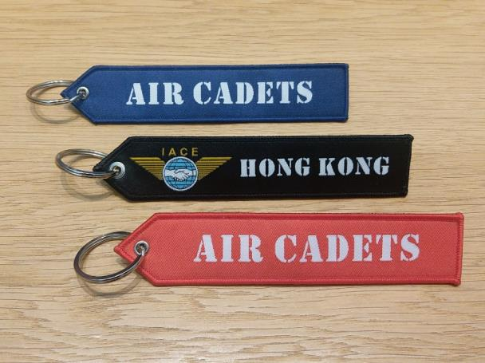
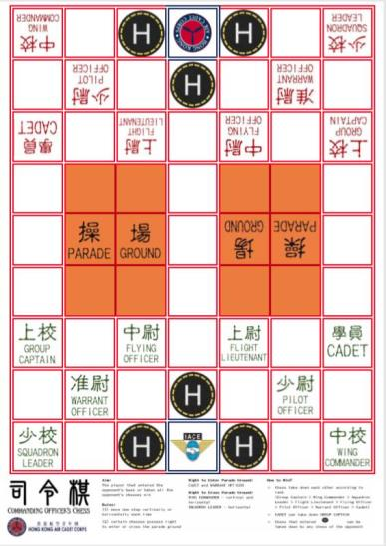
Commanding Officer's Chess IACE-HK Flight Tag Set

HKACC Plastic Folder

